Output:



Fig : Home page

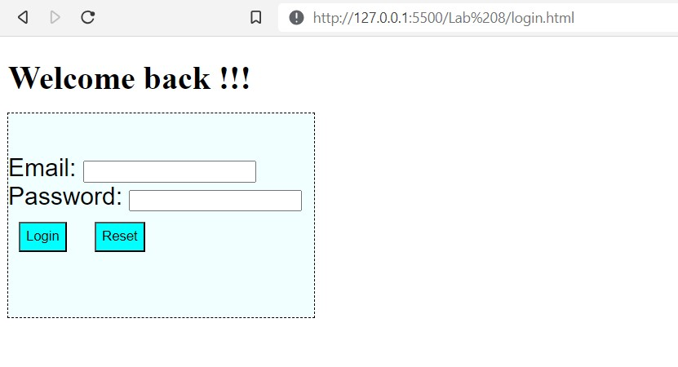

Fig : Login Page

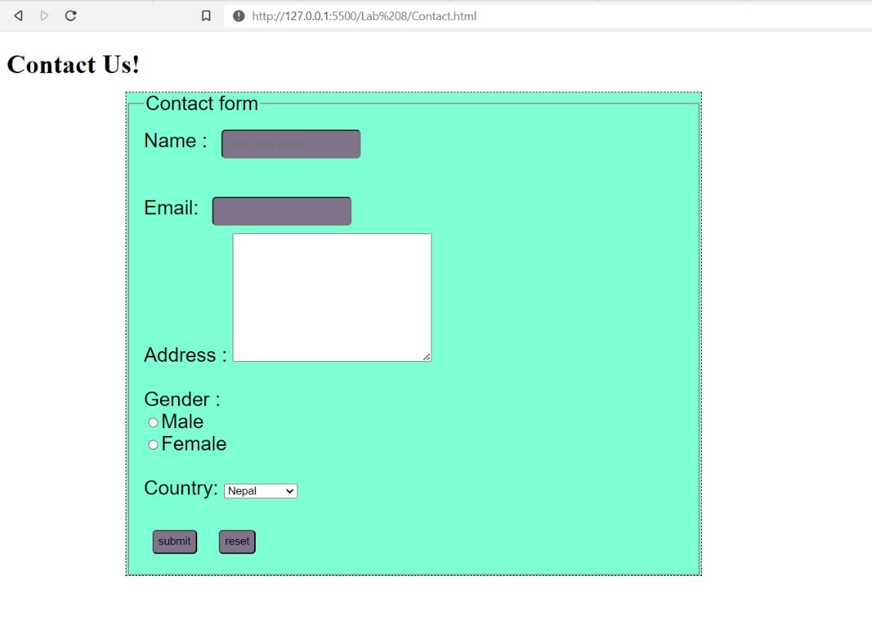

Fig : Contact page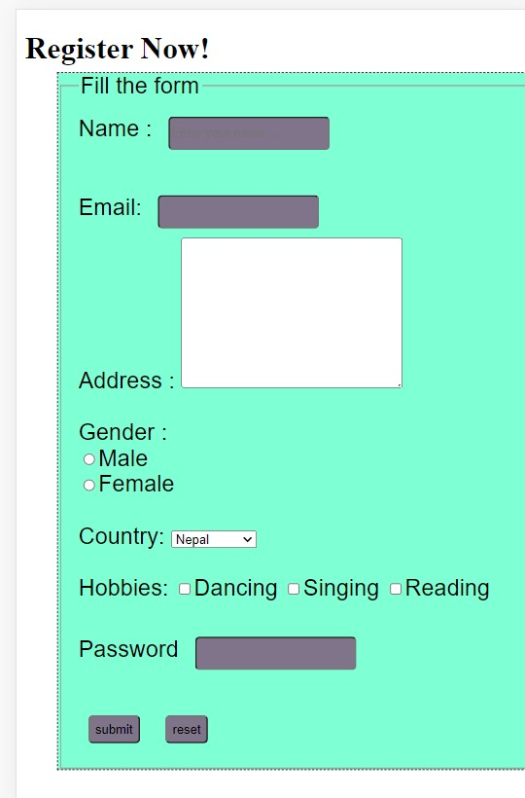

Fig : Register page

Output:

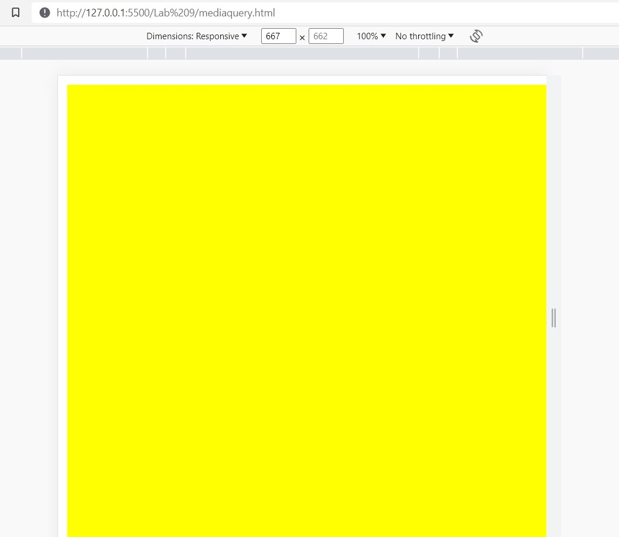 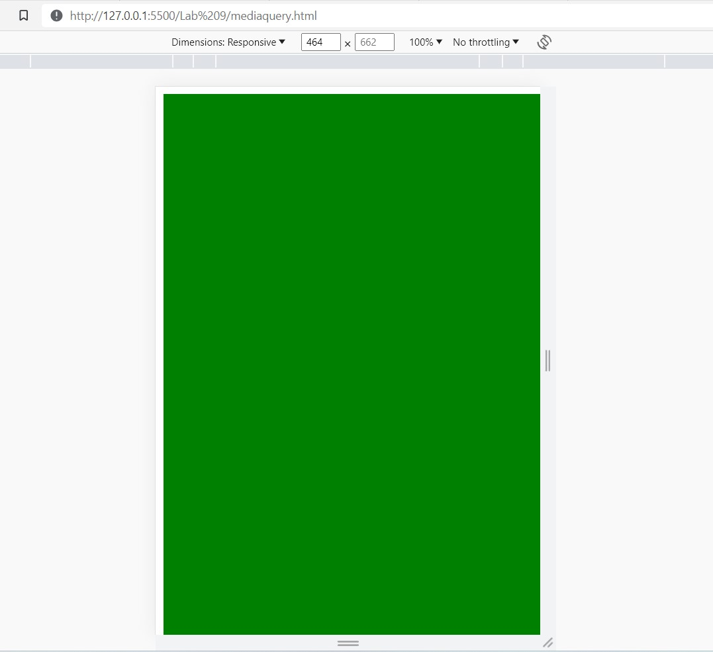

Fig : Viewport at between 500px to 799pixels Fig : Viewport at less than 499 pixels

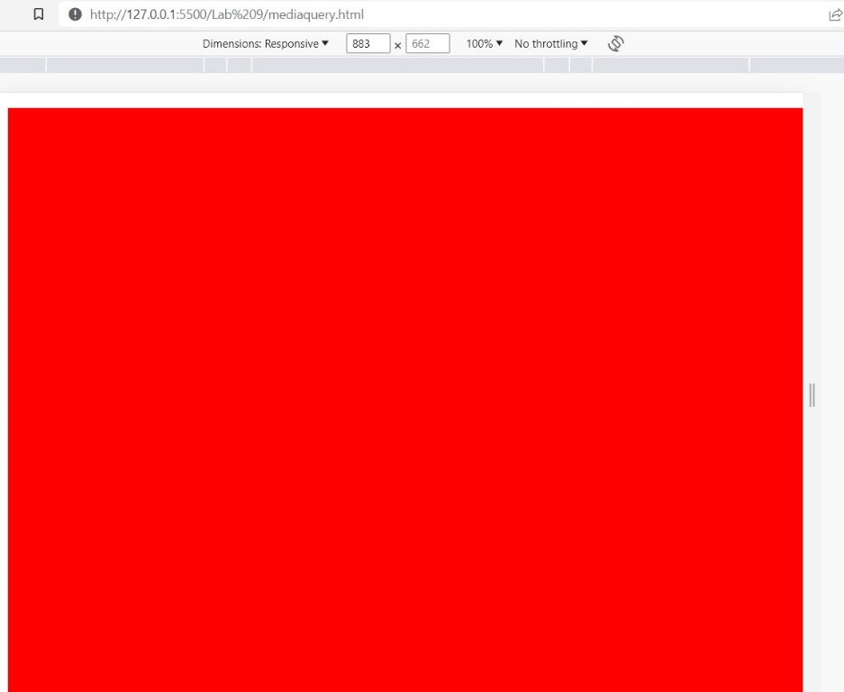

Fig : Viewport at between 800 pixels to 1200 pixels